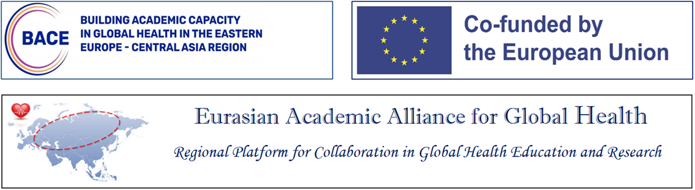

2nd Conference of the
Eurasian Academic Alliance for Global Health

Strengthening Health Workforce for Improving Health Security in the Eurasian Region

Almaty, Kazakhstan
April 16-17, 2024

AGENDA
(draft, sessions/speakers TBC)

April 16, 2024

09:00 - 09:20 | Opening Remarks:  - Aitzhanova Zhamila Nurmatovna, Member of the Board, Vice-Rector for Research and Innovation Activities, Al Farabi Kazakh National University  - Esmagambetova Aizhan Serikbaevna, Vice Minister of Health of the Republic of Kazakhstan, Chief State Sanitary Doctor of the Republic of Kazakhstan.  - Olaf Horstick. Chair of the Board, Eurasian Academic Alliance for Global Health  - George Shakarishvili, Executive Director, Eurasian Academic Alliance for Global Health
09:20 - 09:30 | Overview of the agenda and objectives
09:30 - 10:00 | Overview of the EU/Erasmus Supported Project: Building Academic Capacity in Global Health in the Eastern Europe/Central Asia Region  Jamila Nabieva, University of Heidelberg
10:00 - 11:00 | Session 1: University-based Training Programs  - The European Master in Disaster Medicine (EMDM) is jointly organized by CRIMEDIM - Center for Research and Training in Disaster Medicine, Humanitarian Aid and Global Health of Università del Piemonte Orientale (UPO) and ReGEDiM, the Research Group on Emergency and Disaster Medicine of the Vrije Universiteit Brussel (VUB). The course is aimed at all health professionals involved in the medical disaster management and humanitarian health response at local, national and international level.  American University of Beirut/Humanitarian Leadership Diploma: The Humanitarian Leadership Diploma (HLD) empowers the humanitarian workforce by providing relevant knowledge and skills to address humanitarian disasters based on the identification of the key competencies needed in humanitarian settings.  - KIT/ Analysing Disrupted Health Systems: A residential training course offered by the Royal Tropical Institute (Netherlands) for health professionals focused on the analysis of health systems in countries affected by, or recovering from, protracted crisis, organized jointly with WHO.  Q&A, moderator Prof. Bente Moen, University of Bergen
11:00-11:30 | Break
11:30-12:15 | Session 2: Non-university Training Programs  - Field Epidemiology Training Program (FETP) is a program established by the US Centers for Disease Control and Prevention that builds capacity in national health service agencies by training the public health workforce in field epidemiology and other public health competencies. FETPs have been established in over 90 countries.  - Health Emergencies in Large Populations (H.E.L.P) - a course on humanitarian assistance during disasters, armed conflicts and other complex crises, created by the International Committee of the Red Cross (ICRC) in partnership with WHO and the University of Geneva.  - Asia-Pacific Consortium of Veterinary Epidemiology (APCOVE) works with country partners to strengthen their existing on-the-job training programs for veterinarians in outbreak investigation and surveillance through e-Learning modules and case studies on outbreak investigation, surveillance, data analysis, risk analysis, One Health, biosecurity, leadership and communication.  Q&A, moderator Olaf Horstick, University of Heidelberg
12:30-13:30 | Lunch
13:30 – 14:30 | Session 3: International Initiatives Supporting Health Workforce Development  - Association of Schools and Programs of Public Health  - Association of Schools of Public Health in the European Region  - Consortium of Universities for Global Health  Q&A: Moderator Erik Anda, UiT the Arctic University of Norway
14:30 -15:30 | Session 4: Protecting Public Health: Case Studies of Effective and Efficient Utilization of Health Workforce in the Eurasian Region  - Organizing health workforce for emergency medical care in Ukraine in the context of challenges of peacetime and wartime emergencies  - National initiative on preventing led contamination in women and children in Georgia  - Medical errors and prevention strategies in Kazakhstan  - Public Health Emergency Program of the Eastern Mediterranean Public Health Network  Q&A: Moderator Jamila Nabieva, Heidelberg University
15:30 – 15:45 | Break
15:45 – 16:45 | Session 5: Current Activities and Potential Opportunities for Building Global Health Workforce in the Eurasian Region  - Doctoral program on Global Health at the Nazarbayev University, Kazakhstan  - Institute of Global and European Health Education, University of Georgia  - Informatics and Data Science for Health (IDASH) Fellowship - experience of implementation in Easter European and Asian Region  - Developing a Regional Hub for Capacity Building in Systematic Reviews  Q&A: Moderator Bente Moen Bergen University
16:45- 17:00 | Wrap-up: Olaf Horstick

April 17, 2024
9:30 - 10:30 | Session 6: Public Health Workforce Development in the Republic of Kazakhstan: Current Approaches and Opportunities
- Public health workforce strategy of RK
- System of public health education in RK
- Health workers’ burnout – a new pandemic?
- Protecting health workers from occupational risks

Q&A: Moderator
10:30 – 12:30 | Session 7: Board meeting of the Eurasian Academic Alliance for Global Health (by invitation only)
12:30 – 13:30 | Lunch meeting of the Alliance’s Board

